**3rd Week Assignment**

**by**

**Jui Ying Lee**

**ITC 6355 Web Application Design & Development**

**Professor Amin Karimpour**

**June 13, 2022**

**Project Description**

The project I would like to implement is an online market management system focusing on trading trending clothes or shoes. This small business named as “Delphpreme” which is owned by my husband and his friends. The reason why I choose this project is I want to design an user-friendly system/platform for all people to use and also build a community for everyone to share their experiences.

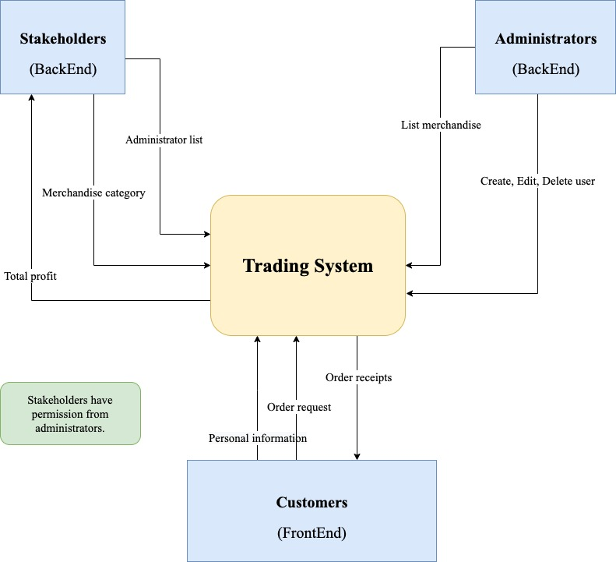The website will operate similar to a stock market-style platform and enable for buyer to bids the items they like and also sellers can list their items for sale. From designing the components, the trading system will have to pass and receive important data from both Backend and Frontend. It will be clear to know who and what’s the responsibilities will be include in the system diagram:

*(Figure 1: System Diagram)*

The scope that will be implemented from Login page to transaction page. In each pages, user will see the tips for each features such as tags, category lists…etc. Detail pages drafted as below:

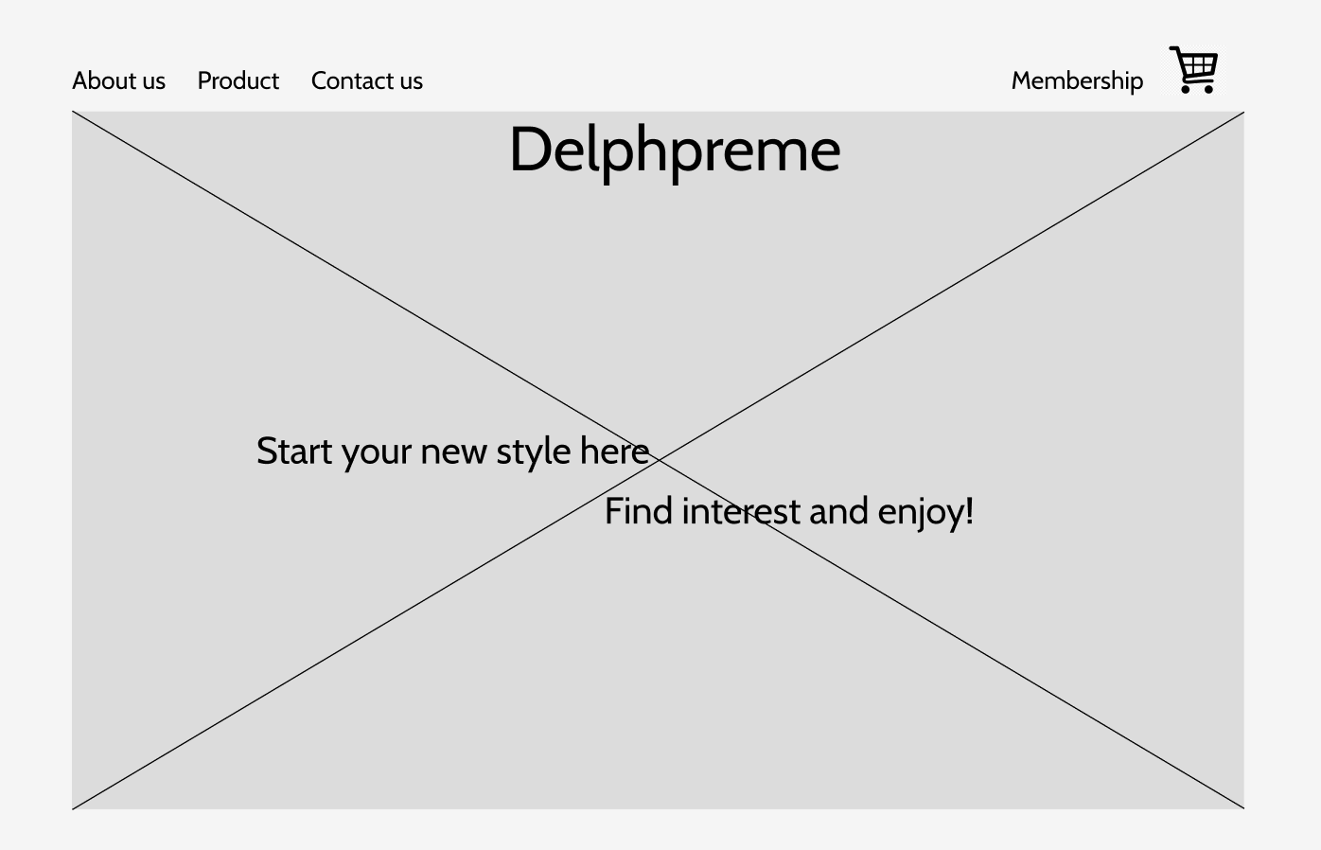

*Figure 2, Homepage*

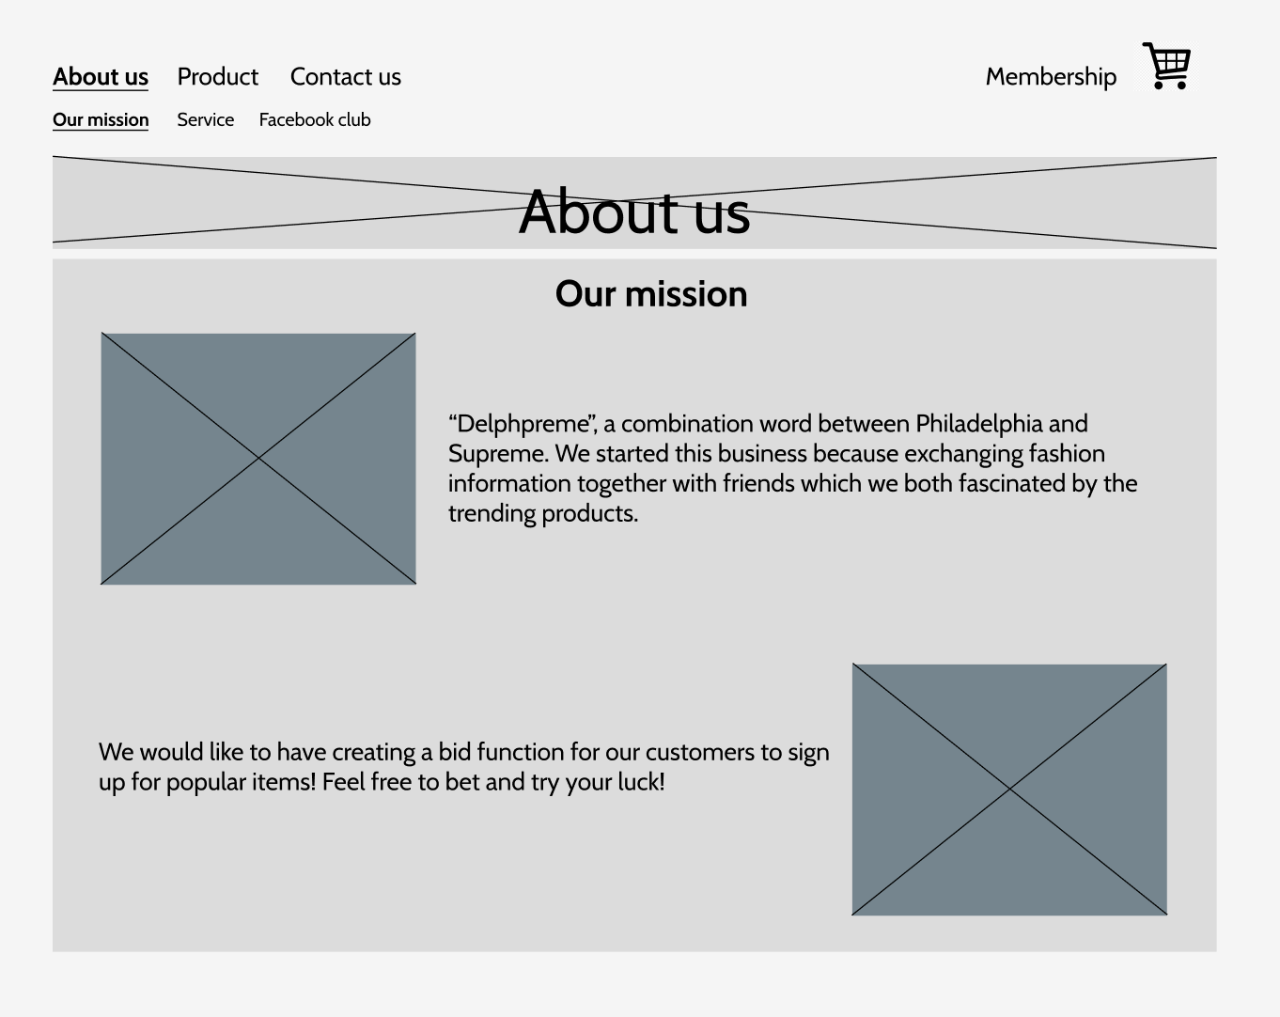

*Figure 3, About us*

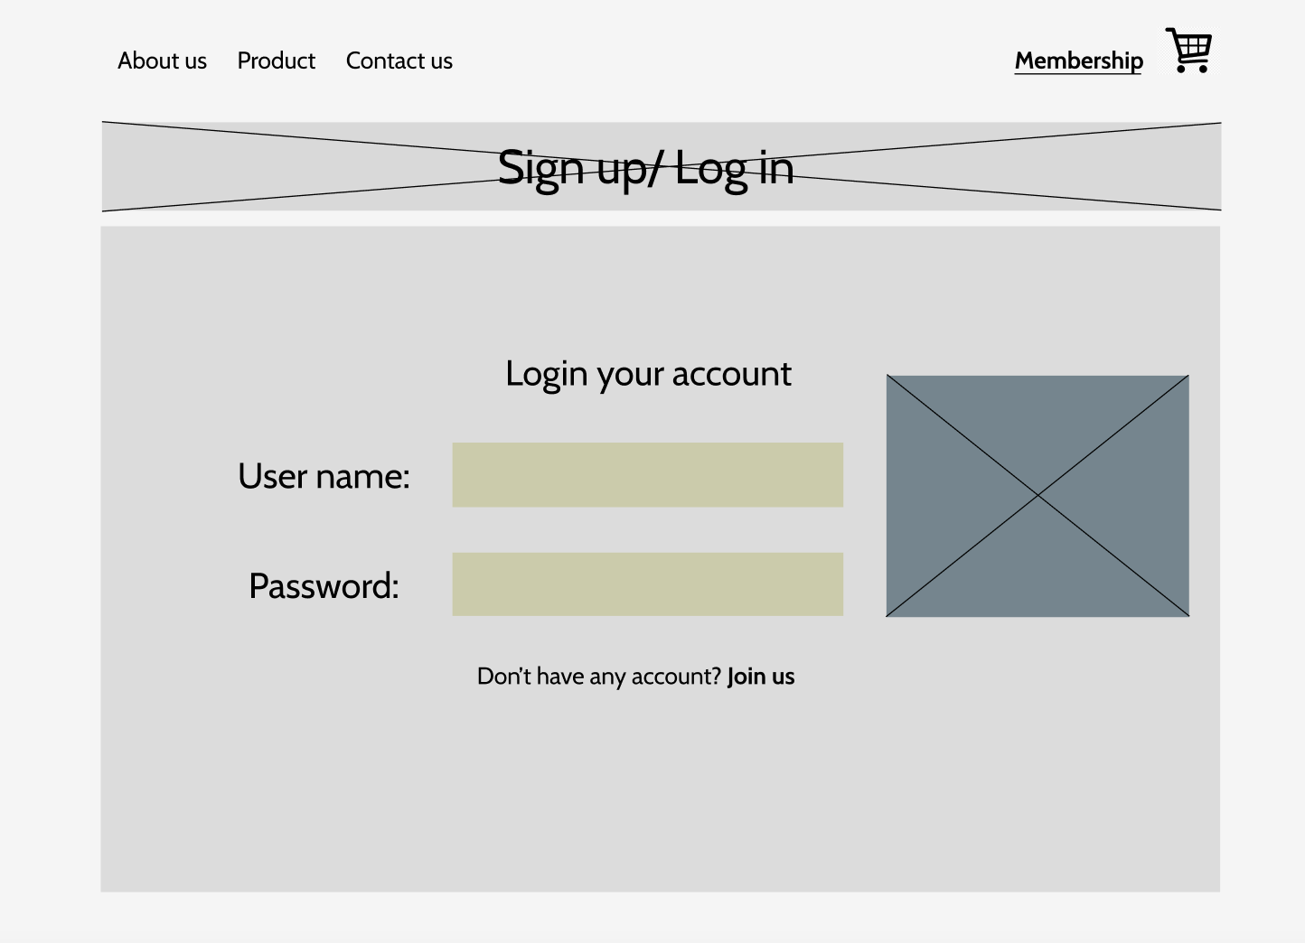

*Figure 4, Sign up/Log in*

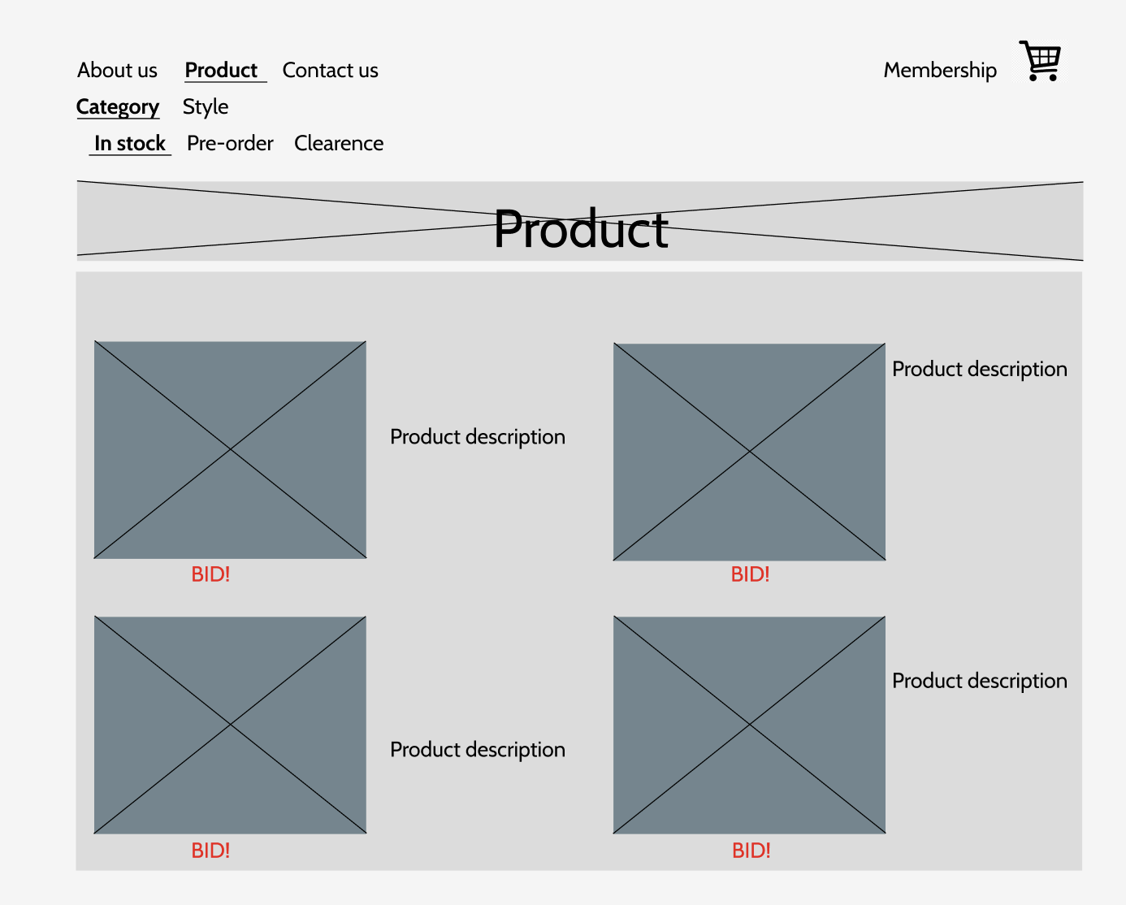

*Figure 5, Product list page*

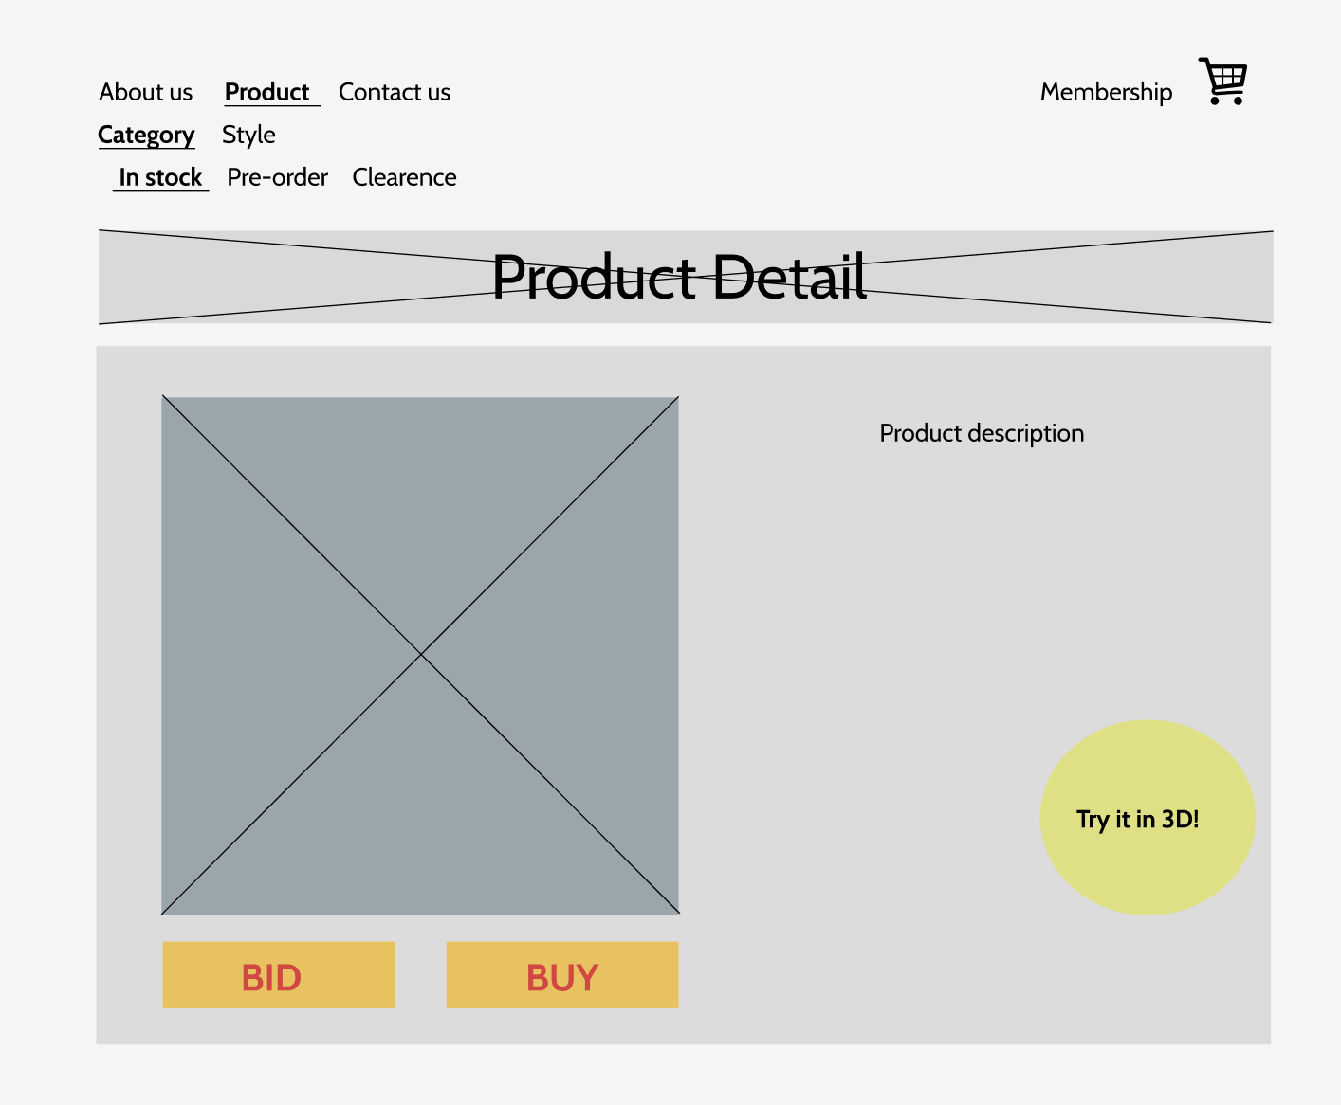

*Figure6, Product detail page*

In each page like About us, user will learn the history of the business, services introductions and Facebook club external links displayed at the top of the category lists which they can be directed to by clicking the button. The drafted menu lists is designed as below sitemap:

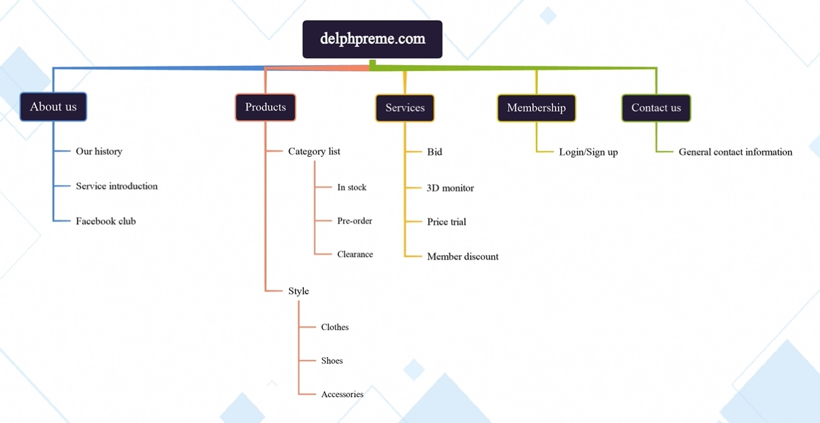

**Project Implementation:**

**HTML5/CSS**

Changes:

* Add contact us and join us page into both HTML and CSS
* Implement JavaScript -> main.js, for better user experience

1. **Home page - HTML:**

<!DOCTYPE *html*>

<html>

<head>

<meta *charset*="UTF-8" />

<meta *name*="viewport" *content*="width=device-width, initial-scale=1.0" />

<title>Delphpreme - Home</title>

<link *rel*="stylesheet" *href*="/styles/homepage.css" *type*="text/css" />

<link

*href*="https://fonts.googleapis.com/css2?family=Playfair:ital,wght@1,500&family=Tilt+Prism&display=swap"

*rel*="stylesheet"

/>

</head>

<body>

<header>

<div *class*="top-bar">

<div *class*="left-side">

<ul *class*="categories">

<li><a *href*="aboutus.html">About us</a></li>

<li><a *href*="productlist.html">Product page</a></li>

<li><a *href*="contactus.html">Contact us</a></li>

<li><a *href*="membership.html" *class*="membership icon">Membership</a></li>

<li><a *href*="#" *class*="cart icon">Cart</li></a>

</ul>

</div>

</header>

<p *class*="join-now">

Don't have an account? <a *href*="joinus.html">Join us now</a>

</p>

</section>

*<!-- Link back to the homepage -->*

<a *href*="homepage.html" *class*="back-to-home">Back to Home</a>

*<!-- Other content of the homepage -->*

</body>

</html>

**Home Page – CSS:**

a {

color: grey;

font-family: "Tilt Prism", cursive;

font-size: 30px;

text-align: center;

}

a*.membership.icon* {

color: orange;

font-family: "Tilt Prism", cursive;

font-size: 30px;

text-align: right;

}

a*.cart.icon* {

color: orange;

font-family: "Tilt Prism", cursive;

font-size: 30px;

text-align: right;

}

h1 {

color: black;

font-family: "Playfair", serif;

font-size: large;

text-align: center;

}

*.categories* {

display: flex;

justify-content: space-between;

}

body {

background-image: url("/images/jordan2.jpeg");

background-size: cover;

background-repeat: no-repeat;

width: 900px;

height: 900px;

margin: 0 auto;

background-color: aliceblue;

padding: 0 40px 40px 40px;

border: 5px solid black;

}

*.join-now*,

*.back-to-home* {

position: fixed;

left: 0;

right: 0;

text-align: center;

bottom: 20px;

}

*.back-to-home* {

bottom: 0;

}

**Home Page – Live Browser:**

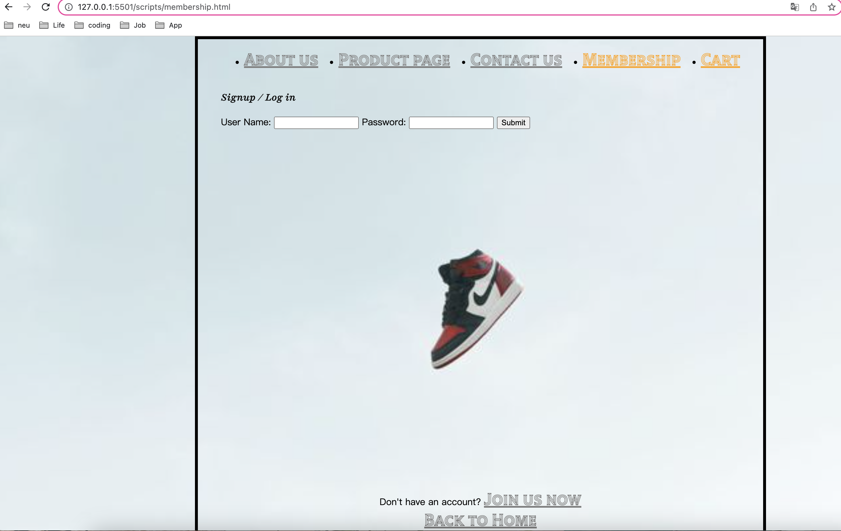

* **About Us Page - HTML:**

<!DOCTYPE *html*>

<html>

<head>

<meta *charset*="UTF-8" />

<meta *name*="viewport" *content*="width=device-width, initial-scale=1.0" />

<title>Delphpreme - About Us</title>

<link *rel*="stylesheet" *href*="/styles/aboutus.css" *type*="text/css" />

<link

*href*="https://fonts.googleapis.com/css2?family=Playfair:ital,wght@1,500&family=Tilt+Prism&display=swap"

*rel*="stylesheet"

/>

</head>

<body>

<header>

<div *class*="top-bar">

<div *class*="left-side">

<ul *class*="categories">

<li><a *href*="aboutus.html">About us</a></li>

<li><a *href*="productlist.html">Product page</a></li>

<li><a *href*="contactus.html">Contact us</a></li>

<li><a *href*="membership.html" *class*="membership icon">Membership</a></li>

</ul>

</div>

</header>

<main>

<section *class*="page-title">

<h1>About Us</h1>

</section>

<section *class*="content-section">

<div *class*="left-side">

<figure>

<img

*src*="/images/delphpreme.jpg"

*alt*="delphpreme logo"

*width*="500"

*height*="200"

/>

<figcaption>

"Delphpreme" A combination word between Philadelphia and Supreme.

We started this business because exchanging fashion information

together with friends which we both fascinated by the trending

products.

</figcaption>

</figure>

</div>

<section *class*="page-subtitle">

<h2>Our Mission</h2>

</section>

<div *class*="right-side">

<figure>

<img

*src*="/images/onfire.jpeg"

*alt*="On Fire"

*width*="350"

*height*="200"

/>

<figcaption>

We would like to have creating a bid function for our customers to

sign up for popular items! Feel free to bet and try your luck!

</figcaption>

</figure>

</div>

</section>

<p *class*="join-now">

Don't have an account? <a *href*="joinus.html">Join us now</a>

</p>

</section>

*<!-- Link back to the homepage -->*

<a *href*="homepage.html" *class*="back-to-home">Back to Home</a>

<footer>

*<!-- Footer content -->*

</footer>

</body>

</html>

**About Us Page – CSS**

a {

color: grey;

font-family: "Tilt Prism", cursive;

font-size: 30px;

text-align: left;

}

a*.membership.icon* {

color: orange;

font-family: "Tilt Prism", cursive;

font-size: 30px;

text-align: right;

}

a*.cart.icon* {

color: orange;

font-family: "Tilt Prism", cursive;

font-size: 30px;

text-align: right;

}

h1 {

color: black;

font-family: "Playfair", serif;

font-size: larger;

text-align: left;

margin: 0;

padding: 20px 0;

color: black;

}

h2 {

color: black;

font-family: "Playfair", serif;

font-size: larger;

text-align: left;

margin: 0;

padding: 20px 0;

color: black;

}

figcaption {

color: rgb(64, 111, 191);

font-family: "Playfair", serif;

font-size: medium;

text-align: center;

}

*.categories* {

display: flex;

justify-content: space-between;

}

body {

background-image: url("/images/jordan2.jpeg");

background-size: cover;

background-repeat: no-repeat;

width: 900px;

height: 900px;

margin: 0 auto;

background-color: aliceblue;

padding: 0 40px 40px 40px;

border: 5px solid black;

}

img {

display: block;

margin: 0 auto;

}

*.join-now*,

*.back-to-home* {

position: fixed;

left: 0;

right: 0;

text-align: center;

bottom: 20px;

}

*.back-to-home* {

bottom: 0;

}

**About Us Page – Live Browser:**

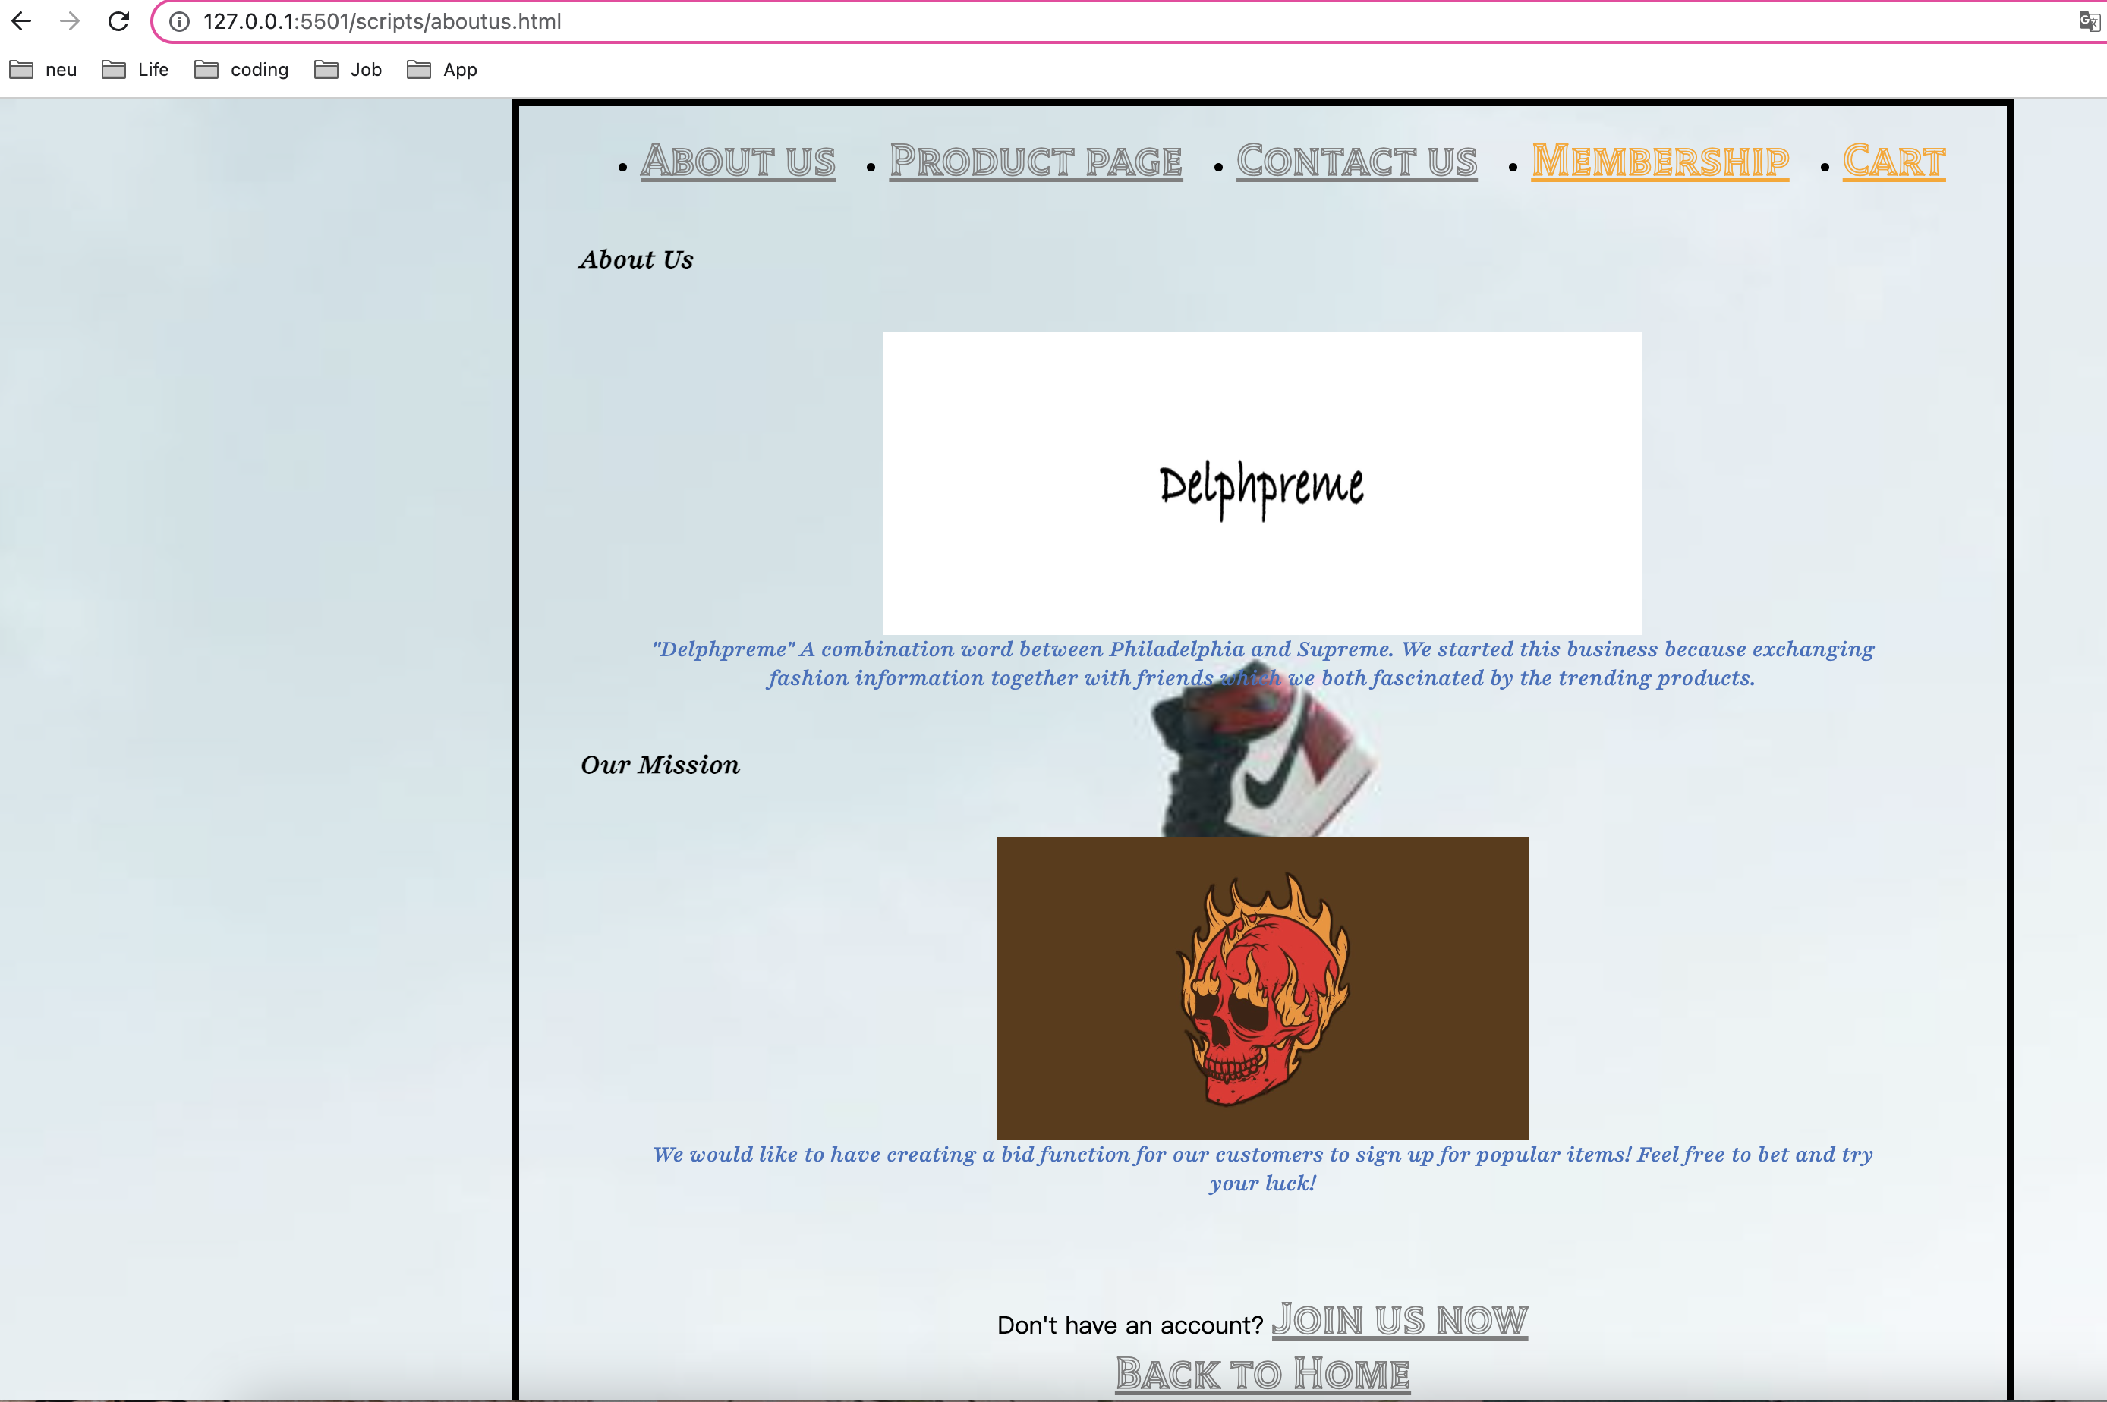

* **Membership page -HTML:**

<!DOCTYPE *html*>

<html>

<head>

<meta *charset*="UTF-8" />

<meta *name*="viewport" *content*="width=device-width, initial-scale=1.0" />

<title>Delphpreme - Membership</title>

<link *rel*="stylesheet" *href*="/styles/membership.css" *type*="text/css" />

<link

*href*="https://fonts.googleapis.com/css2?family=Playfair:ital,wght@1,500&family=Tilt+Prism&display=swap"

*rel*="stylesheet"

/>

</head>

<body>

<header>

<div *class*="top-bar">

<div *class*="left-side">

<ul *class*="categories">

<li><a *href*="aboutus.html">About us</a></li>

<li><a *href*="productlist.html">Product page</a></li>

<li><a *href*="contactus.html">Contact us</a></li>

<li>

<a *href*="membership.html" *class*="membership icon">Membership</a>

</li>

<li><a *href*="#" *class*="cart icon">Cart</a></li>

</ul>

</div>

</div>

</header>

<main>

<section *class*="page-title">

<h1>Signup / Log in</h1>

</section>

<section *class*="membership-form">

<form>

<label *for*="username">User Name:</label>

<input *type*="text" *id*="username" *name*="username" *required* />

<label *for*="password">Password:</label>

<input *type*="password" *id*="password" *name*="password" *required* />

<input *type*="submit" *value*="Submit" />

</form>

<p *class*="join-now">

Don't have an account? <a *href*="joinus.html">Join us now</a>

</p>

</section>

*<!-- Link back to the homepage -->*

<a *href*="homepage.html" *class*="back-to-home">Back to Home</a>

</main>

<footer>

*<!-- Footer content -->*

</footer>

</body>

</html>

**Membership Page – CSS**

a {

color: grey;

font-family: "Tilt Prism", cursive;

font-size: 30px;

text-align: left;

}

a*.membership.icon* {

color: orange;

font-family: "Tilt Prism", cursive;

font-size: 30px;

text-align: right;

}

a*.cart.icon* {

color: orange;

font-family: "Tilt Prism", cursive;

font-size: 30px;

text-align: right;

}

h1 {

color: black;

font-family: "Playfair", serif;

font-size: larger;

text-align: left;

margin: 0;

padding: 20px 0;

color: black;

}

h2 {

color: black;

font-family: "Playfair", serif;

font-size: larger;

text-align: left;

margin: 0;

padding: 20px 0;

color: black;

}

*.join-now*,

*.back-to-home* {

position: fixed;

left: 0;

right: 0;

text-align: center;

bottom: 20px;

}

*.back-to-home* {

bottom: 0;

}

*.categories* {

display: flex;

justify-content: space-between;

}

body {

background-image: url("/images/jordan2.jpeg");

background-size: cover;

background-repeat: no-repeat;

width: 900px;

height: 900px;

margin: 0 auto;

background-color: aliceblue;

padding: 0 40px 40px 40px;

border: 5px solid black;

}

img {

display: block;

margin: 0 auto;

}

**Membership page – Live Browser**

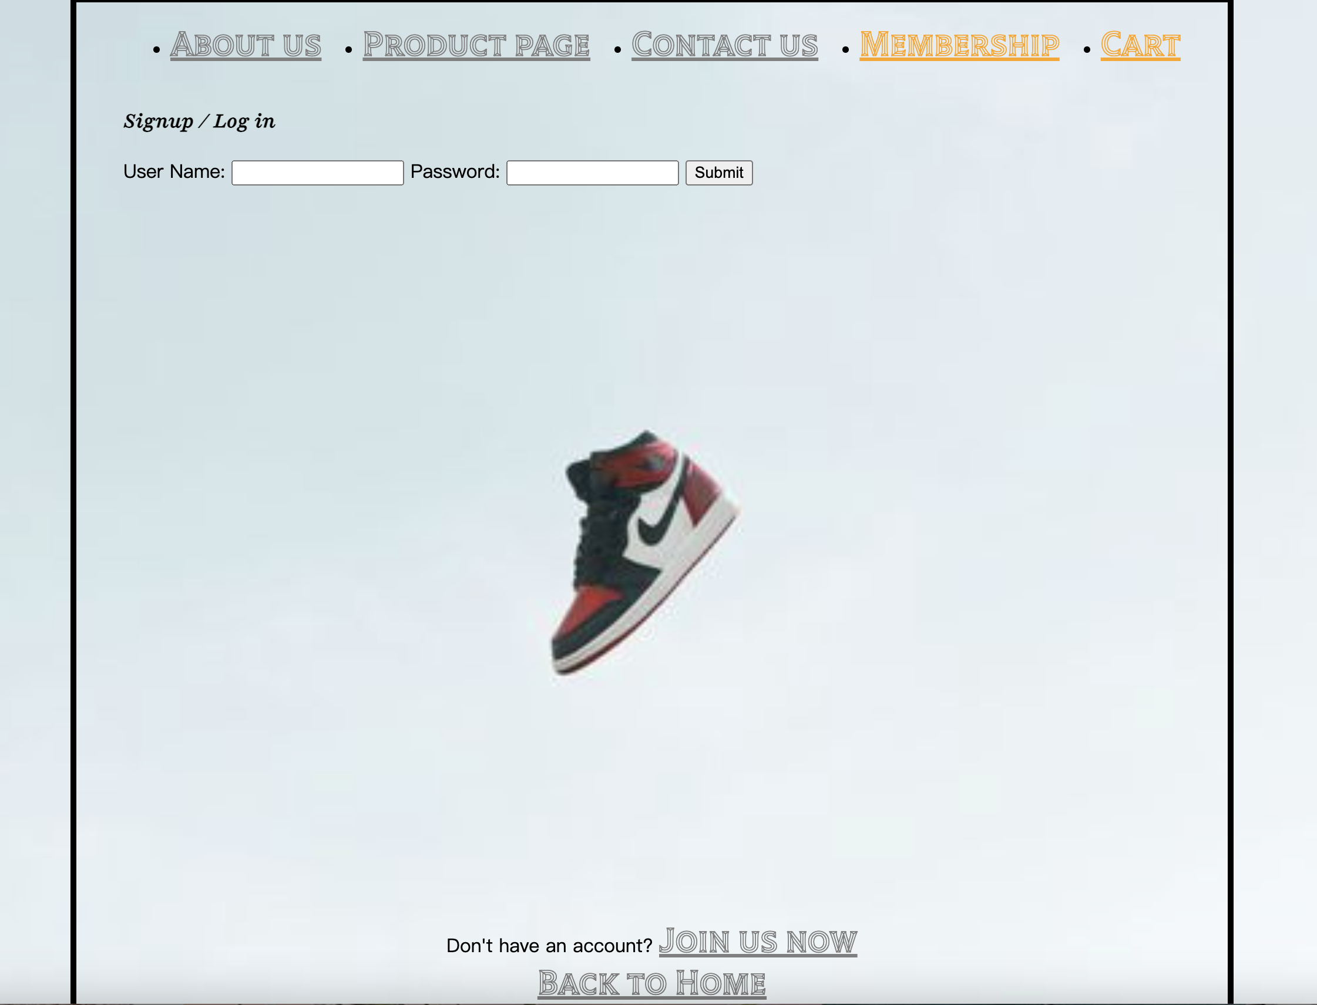

* **Product List Page - HTML:**

<!DOCTYPE *html*>

<html>

<head>

<meta *charset*="UTF-8" />

<meta *name*="viewport" *content*="width=device-width, initial-scale=1.0" />

<title>Delphpreme - Product List</title>

<link *rel*="stylesheet" *href*="/styles/productlist.css" *type*="text/css" />

<link

*href*="https://fonts.googleapis.com/css2?family=Playfair:ital,wght@1,500&family=Tilt+Prism&display=swap"

*rel*="stylesheet"

/>

</head>

<body>

<header>

<div *class*="top-bar">

<div *class*="left-side">

<ul *class*="categories">

<li><a *href*="aboutus.html">About us</a></li>

<li><a *href*="productlist.html">Product page</a></li>

<li><a *href*="contactus.html">Contact us</a></li>

<li><a *href*="membership.html" *class*="membership icon">Membership</a></li>

</ul>

</div>

</header>

<main>

<section *class*="page-title">

<h1>Product</h1>

</section>

<section *class*="product-lists">

<div *class*="left-side1">

<a *href*="productdetail.html">

<figure>

<img *src*="/images/aj1.jpeg" *alt*="product 1" *width*="250" *height*="200" />

<figcaption>The Latest Airjordan 1</figcaption>

</figure>

</a>

</div>

<div *class*="left-side2">

<figure>

<img

*src*="/images/aj2.jpeg"

*alt*="product 2"

*width*="350"

*height*="200"

/>

<figcaption>The Latest Airjordan 1-2</figcaption>

</figure>

</div>

<div *class*="right-side1">

<figure>

<img

*src*="/images/aj3.jpeg"

*alt*="Product 3"

*width*="350"

*height*="200"

/>

<figcaption>The Latest Airjordan 1-3</figcaption>

</figure>

</div>

<div *class*="right-side2">

<figure>

<img

*src*="/images/aj4.jpeg"

*alt*="product 4"

*width*="350"

*height*="200"

/>

<figcaption>The Latest Airjordan 1-4</figcaption>

</figure>

</div>

</section>

*<!-- Link back to the homepage -->*

<a *href*="homepage.html">Back to Home</a>

</main>

<footer>

*<!-- Footer content -->*

</footer>

</body>

</html>

**Product List Page – CSS**

a {

color: grey;

font-family: "Tilt Prism", cursive;

font-size: 30px;

text-align: left;

}

a*.membership.icon* {

color: orange;

font-family: "Tilt Prism", cursive;

font-size: 30px;

text-align: right;

}

a*.cart.icon* {

color: orange;

font-family: "Tilt Prism", cursive;

font-size: 30px;

text-align: right;

}

h1 {

color: black;

font-family: "Playfair", serif;

font-size: xx-large;

text-align: left;

margin: 0;

padding: 20px 0;

color: black;

}

h2 {

color: black;

font-family: "Playfair", serif;

font-size: larger;

text-align: left;

margin: 0;

padding: 20px 0;

color: black;

}

*.join-now*,

*.back-to-home* {

position: fixed;

left: 0;

right: 0;

text-align: center;

bottom: 20px;

}

*.back-to-home* {

bottom: 0;

}

*.categories* {

display: flex;

justify-content: space-between;

}

body {

background-image: url("/images/jordan2.jpeg");

background-size: cover;

background-repeat: no-repeat;

width: 1000px;

height: 1400px;

margin: 0 auto;

background-color: aliceblue;

padding: 0 40px 40px 40px;

border: 5px solid black;

}

img {

display: block;

margin: 0 auto;

}

figcaption {

color: red;

display: flex;

justify-content: center;

align-items: center;

}

**Product List Page – Live Browser:**

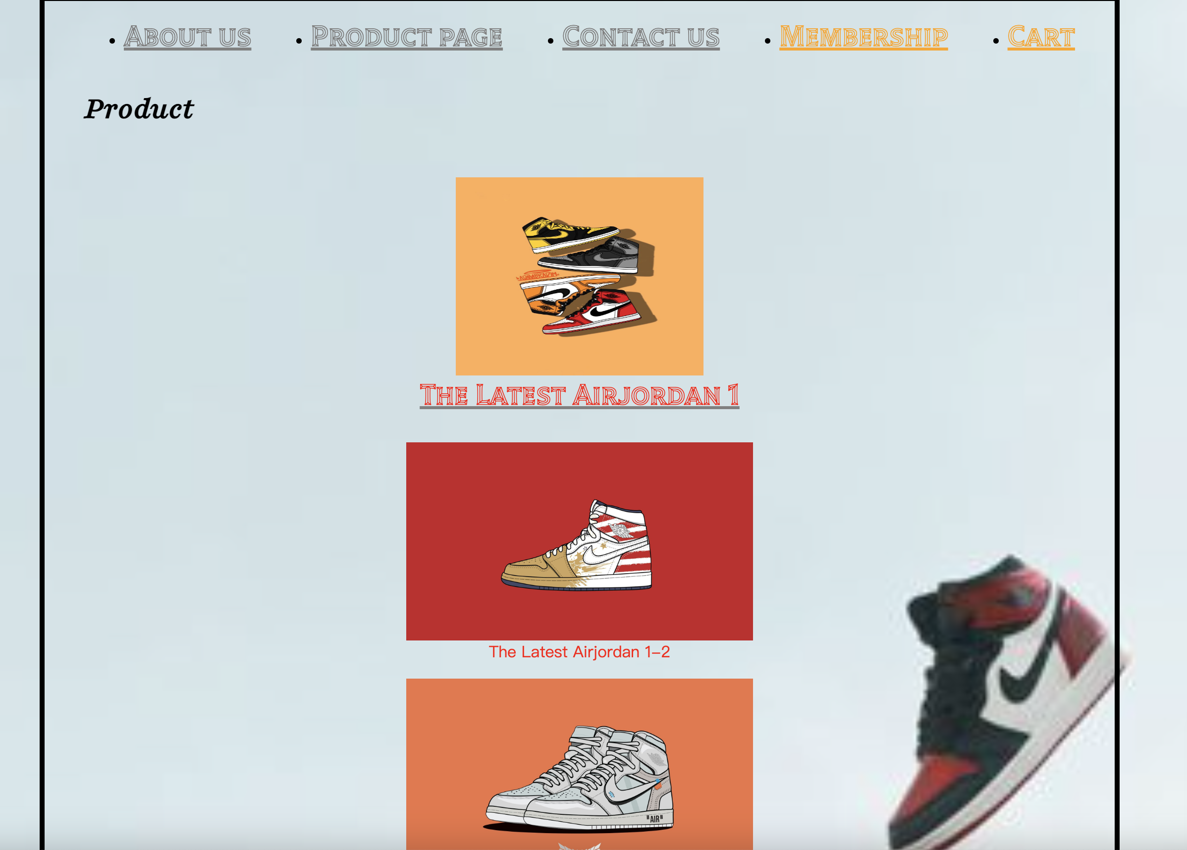

* **Product Detail Page - HTML:**

<!DOCTYPE *html*>

<html>

<head>

<meta *charset*="UTF-8" />

<meta *name*="viewport" *content*="width=device-width, initial-scale=1.0" />

<title>Delphpreme - Product Detail</title>

<link *rel*="stylesheet" *href*="/styles/productdetail.css" *type*="text/css" />

<link

*href*="https://fonts.googleapis.com/css2?family=Playfair:ital,wght@1,500&family=Tilt+Prism&display=swap"

*rel*="stylesheet"

/>

</head>

<body>

<header>

<div *class*="top-bar">

<div *class*="left-side">

<ul *class*="categories">

<li><a *href*="aboutus.html">About us</a></li>

<li><a *href*="productlist.html">Product page</a></li>

<li><a *href*="contactus.html">Contact us</a></li>

</ul>

</div>

<div *class*="right-side">

<a *href*="membership.html" *class*="membership">Membership</a>

<a *href*="#" *class*="cart-icon">Cart</a>

</div>

</div>

</header>

<main>

<section *class*="product-detail">

<div *class*="left-side">

<figure>

<img

*src*="/images/aj1.jpeg"

*alt*="Product 1"

*width*="400"

*height*="350"

/>

</figure>

</div>

<div *class*="right-side">

<h2>Air Jordan 1</h2>

<p *class*="product-description">Retro Style of Nike, Air Jordan.</p>

<div *class*="buttons">

<button *class*="bid-button">BID</button>

<button *class*="buy-button">BUY</button>

</div>

</div>

</section>

<button *class*="try-3d-button">Try it in 3D!</button>

*<!-- Link back to the homepage -->*

<a *href*="homepage.html">Back to Home</a>

</main>

<footer>

*<!-- Footer content -->*

</footer>

</body>

</html>

**Product Detail Page – CSS:**

a {

color: grey;

font-family: "Tilt Prism", cursive;

font-size: 30px;

text-align: left;

}

a*.membership.icon* {

color: orange;

font-family: "Tilt Prism", cursive;

font-size: 30px;

text-align: right;

}

a*.cart.icon* {

color: orange;

font-family: "Tilt Prism", cursive;

font-size: 30px;

text-align: right;

}

h1 {

color: black;

font-family: "Playfair", serif;

font-size: larger;

text-align: left;

margin: 0;

padding: 20px 0;

color: black;

}

h2 {

color: black;

font-family: "Playfair", serif;

font-size: larger;

text-align: left;

margin: 0;

padding: 20px 0;

color: black;

}

*.join-now*,

*.back-to-home* {

position: fixed;

left: 0;

right: 0;

text-align: center;

bottom: 20px;

}

*.back-to-home* {

bottom: 0;

}

*.categories* {

display: flex;

justify-content: space-between;

}

body {

background-image: url("/images/jordan2.jpeg");

background-size: cover;

background-repeat: no-repeat;

width: 1000px;

height: 1400px;

margin: 0 auto;

background-color: aliceblue;

padding: 0 40px 40px 40px;

border: 5px solid black;

}

img {

display: block;

margin: 0 auto;

}

**Product Detail Page – Live Browser:**

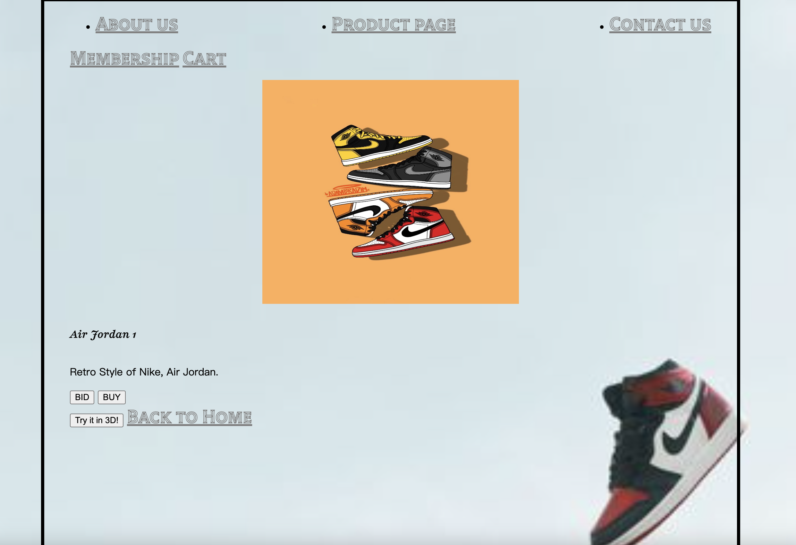

**JavaScript**

(Saving file as main.js)

document.addEventListener("DOMContentLoaded", function () {

const form = document.getElementById("membership-form");

form.addEventListener("submit", function (event) {

event.preventDefault();

validateForm();

});

function validateForm() {

const firstnameInput = document.getElementById("firstname");

const lastnameInput = document.getElementById("lastname");

const usernameInput = document.getElementById("username");

const passwordInput = document.getElementById("password");

const emailInput = document.getElementById("email");

const phoneInput = document.getElementById("phone");

const firstname = firstnameInput.value.trim();

const lastname = lastnameInput.value.trim();

const username = usernameInput.value.trim();

const password = passwordInput.value.trim();

const email = emailInput.value.trim();

const phone = phoneInput.value.trim();

*// Reset previous error messages*

resetErrorMessages();

*// Perform validation checks*

let isValid = true;

*if* (!isValidName(firstname)) {

displayErrorMessage(firstnameInput, "Invalid first name");

isValid = false;

}

*if* (!isValidName(lastname)) {

displayErrorMessage(lastnameInput, "Invalid last name");

isValid = false;

}

*if* (!isValidUsername(username)) {

displayErrorMessage(usernameInput, "Invalid username");

isValid = false;

}

*if* (!isValidPassword(password)) {

displayErrorMessage(passwordInput, "Invalid password");

isValid = false;

}

*if* (!isValidEmail(email)) {

displayErrorMessage(emailInput, "Invalid email address");

isValid = false;

}

*if* (!isValidPhoneNumber(phone)) {

displayErrorMessage(phoneInput, "Invalid phone number");

isValid = false;

}

*// If the form is valid, submit it*

*if* (isValid) {

form.submit();

}

}

function resetErrorMessages() {

const errorMessages = document.querySelectorAll(".error-message");

errorMessages.forEach(function (errorMessage) {

errorMessage.remove();

});

}

function displayErrorMessage(inputElement, message) {

const errorContainer = document.createElement("div");

errorContainer.classList.add("error-container");

const errorMessage = document.createElement("span");

errorMessage.classList.add("error-message");

errorMessage.textContent = message;

errorContainer.appendChild(errorMessage);

inputElement.parentNode.insertBefore(

errorContainer,

inputElement.nextSibling

);

}

function isValidName(name) {

*// Check if the name contains any numbers*

*return* !/\d/.test(name);

}

function isValidUsername(username) {

*// Add your username validation logic here*

*return* /*^*[a-zA-Z0-9]+*$*/.test(username);

}

function isValidPassword(password) {

*// Add your password validation logic here*

*return* /*^*[a-zA-Z0-9]+*$*/.test(password);

}

function isValidEmail(email) {

*// Add your email validation logic here*

*return* /*^*[^\s@]+@[^\s@]+\.[^\s@]+*$*/.test(email);

}

function isValidPhoneNumber(phone) {

*// Add your phone number validation logic here*

*return* /*^*[0-9]+*$*/.test(phone);

}

});

In Live Browser (in join us page):

